
Version 1.0
Dualog AS
16. november 2021
Confidentiality
IMAP Migration Tool
  - Teekay
© 2021 Dualog AS.
All rights reserved.

No part of this publication may be reproduced,
stored in a retrieval system, or transmitted, in any
form or by any means, mechanical, electronic,
photocopying, recording, or otherwise, without
prior written permission of Dualog AS.

Dualog AS
Alkeveien 14
9015 Tromsø, Norway

Document History
Date | Version | Author | Comment
16.11.2021 | 1.0 | Darren
Document Approval
Date | Version | Approved By | Title

The IMAP migration Tool

The imap migration tool enables the restoration of imap data file that is not associated with items in the backup by remapping of user IDs to match the user IDs in the new vessel startpack configuration.

The Toolkit includes the following files
1. 7z.dll
2. 7z.exe
3.ChangeBackupMessageOwners.cmd
4. DualogUserMap.exe
A unique mapping configuration : DualogUserMap.ini will be provided seperately by Dualog Support which defines the actual user IDs mapping between the current vessel configuration correspording to the vessel under the new organisation for each vessel migration.

Execution
- Extract all files in IMAP_Script.zip to C:\tool\
- Save : DualogUserMap.ini to C:\tool\
- Save all IMAP Data files to C:\DualogBackup\
- Run MS Prompt and navigate to C:\
- Run command : C:\tool\ChangeBackupMessageOwners.cmd and press “Enter” key
- The Process may take up to 30 mins for remapping of Users in the IMAP data files to complete
- Once completed, login to Dualog Connection Suite Ship Portal and navigate to “Technical Setup”
- Perform IMAP Restoration as per normal procedure by clicking on “Restore Backup” button
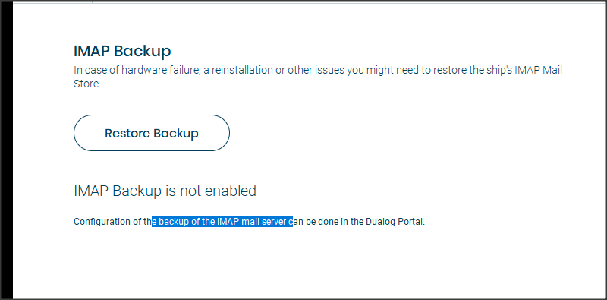
- Specify the Backup directory to D:\DualogBackup\imapmailstore.dualogbackup.archive and click on “Restore Backup” Button
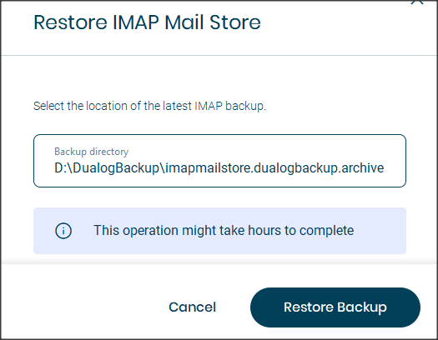
- The Imap Restoration may take several hours to complete

Please contact Dualog support if you encounter any issue with the IMAP migration process.

